**Skills Demonstration 1**

**Graphical User Interface Programming**

**Weighting: 30%**

**Code: 6N0736**

**Date: 10/02/2020**

**Computer Science 2019-2020**

**Tutor: Deirdre Shaw**

Contents

End User Guide 3

Main Form 4

About Form 4

Word Processor Form 5

Calculator Form 6

Picture Viewer Form 6

Drag and Drop Form 6

Web Browser Form 6

# End User Guide

Creator of Application: Denis Inwood  
Author of User Guide: Denis Inwood

Forms to View:

Main Form

About Form

Word Processor Form

Calculator Form

Picture Viewer Form

Drag and Drop Form

Web Browser Form

## Main Form

This is the user guide for a simple to use application that contains 5 different programs and an about form to tell you about the application. First I will talk you through about how to use the main Form/Menu. The menu has 6 buttons that are labelled to tell you which application they lead to (Fig 1). You can also open each of the Programs through the file menu strip at the top of the application as well as being able to close the application (Fig 2). Then the last thing is that you can change the background colour of the menu form in the edit menu strip at the top (Fig 3).

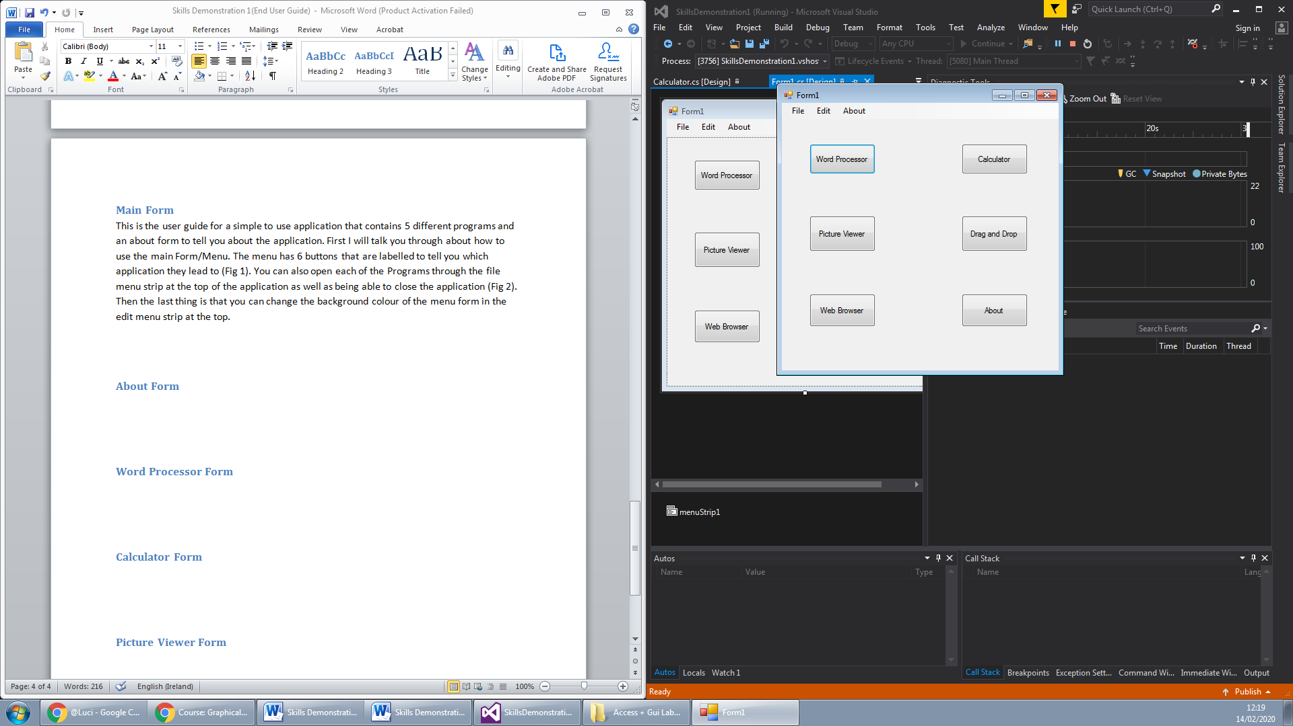 (Fig 1)

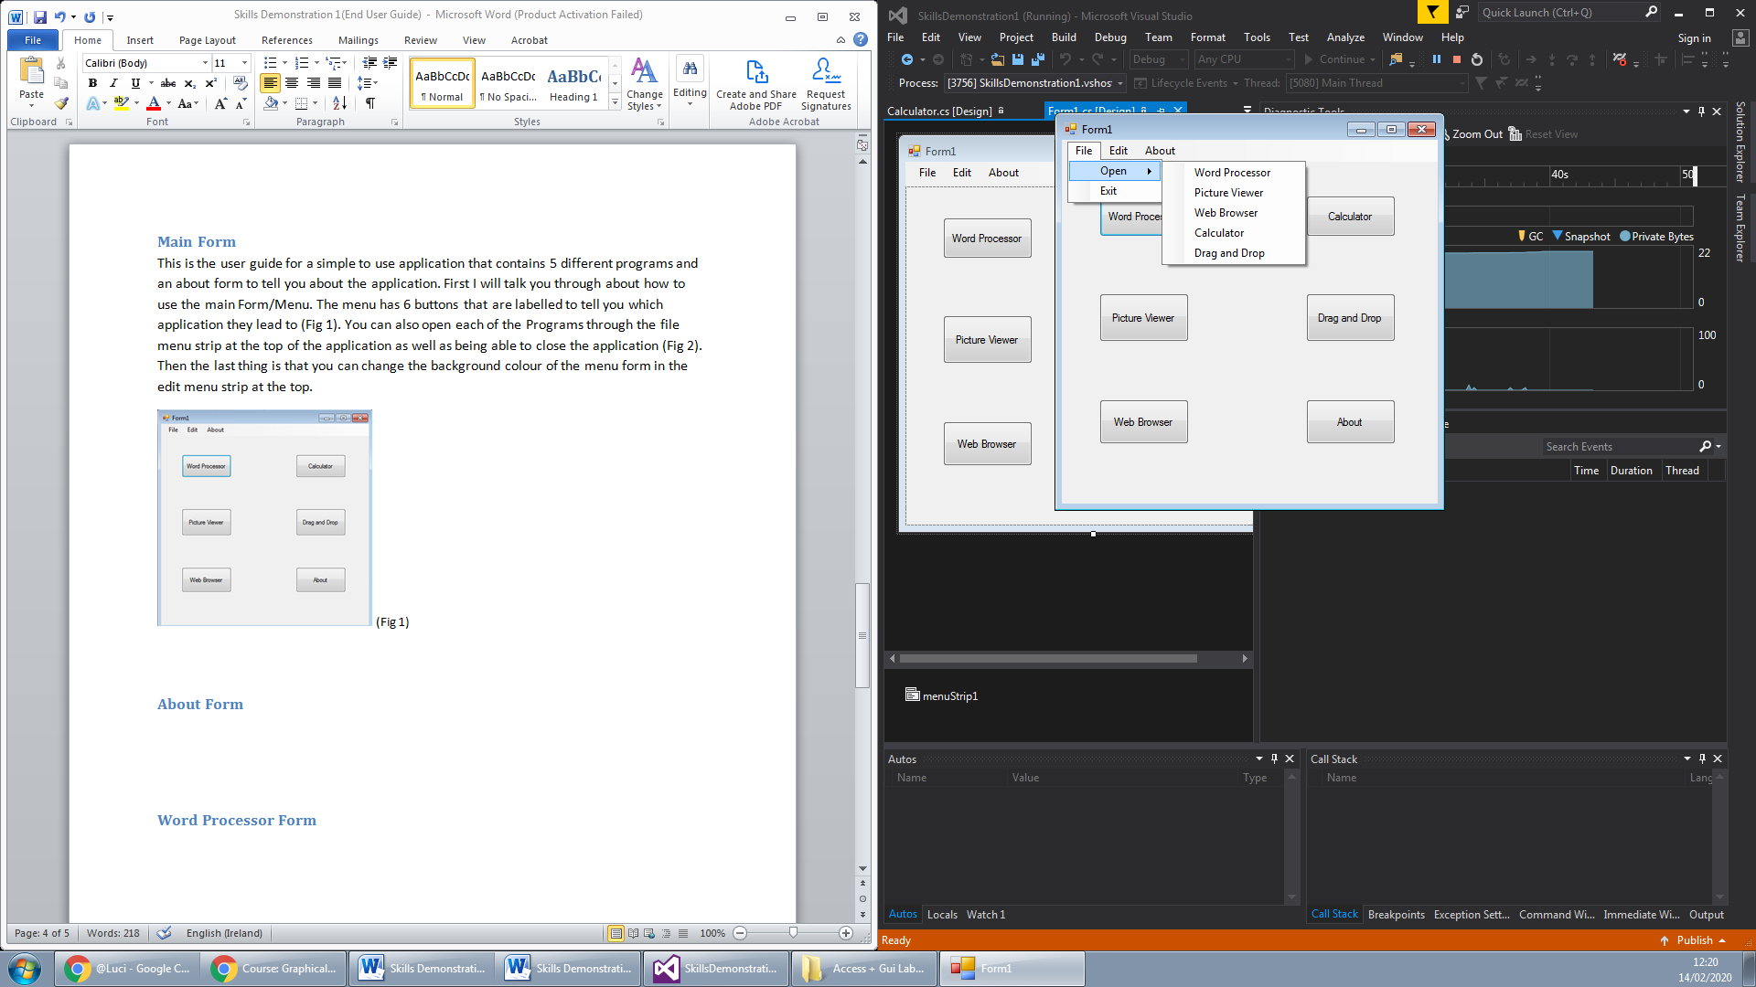 (Fig 2)

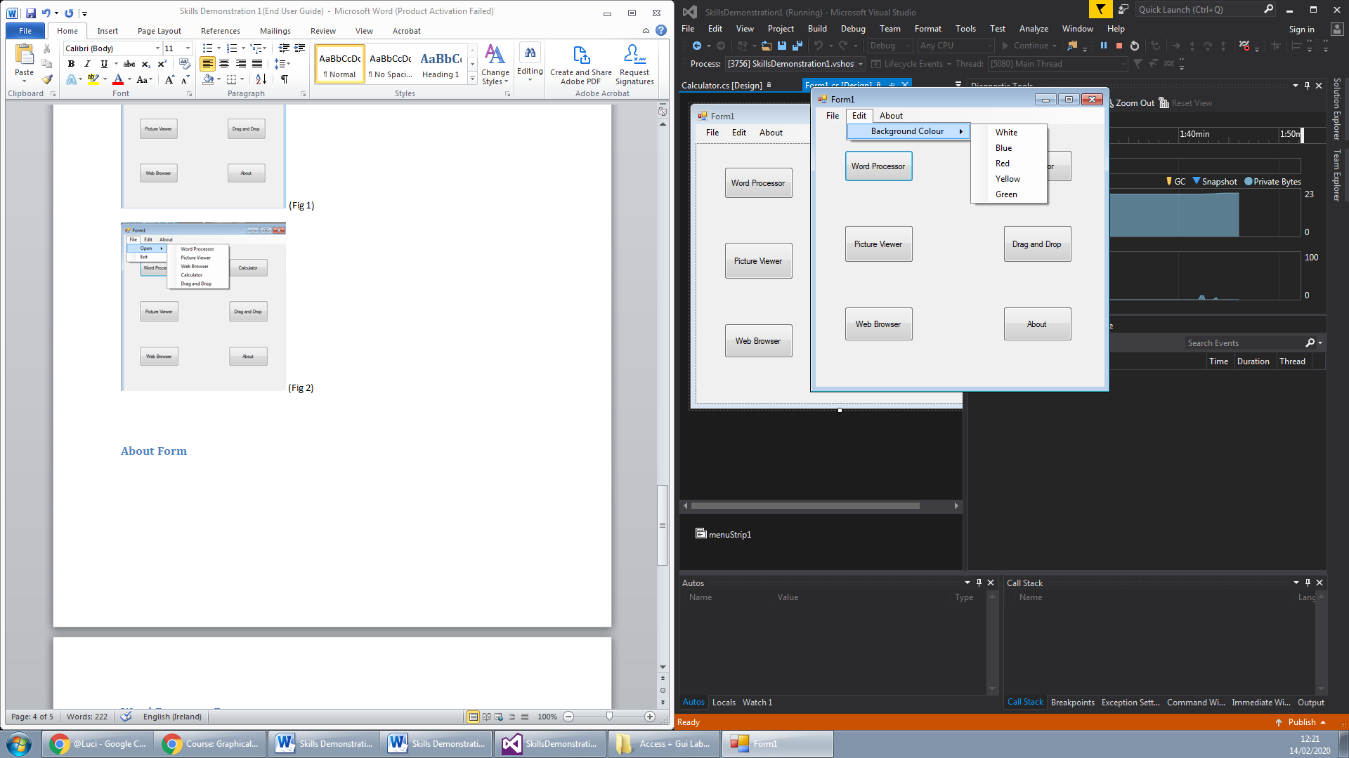 (Fig 3)

## About Form

The about form tells the user about who created the application and explains the purpose of the application (Fig 4).

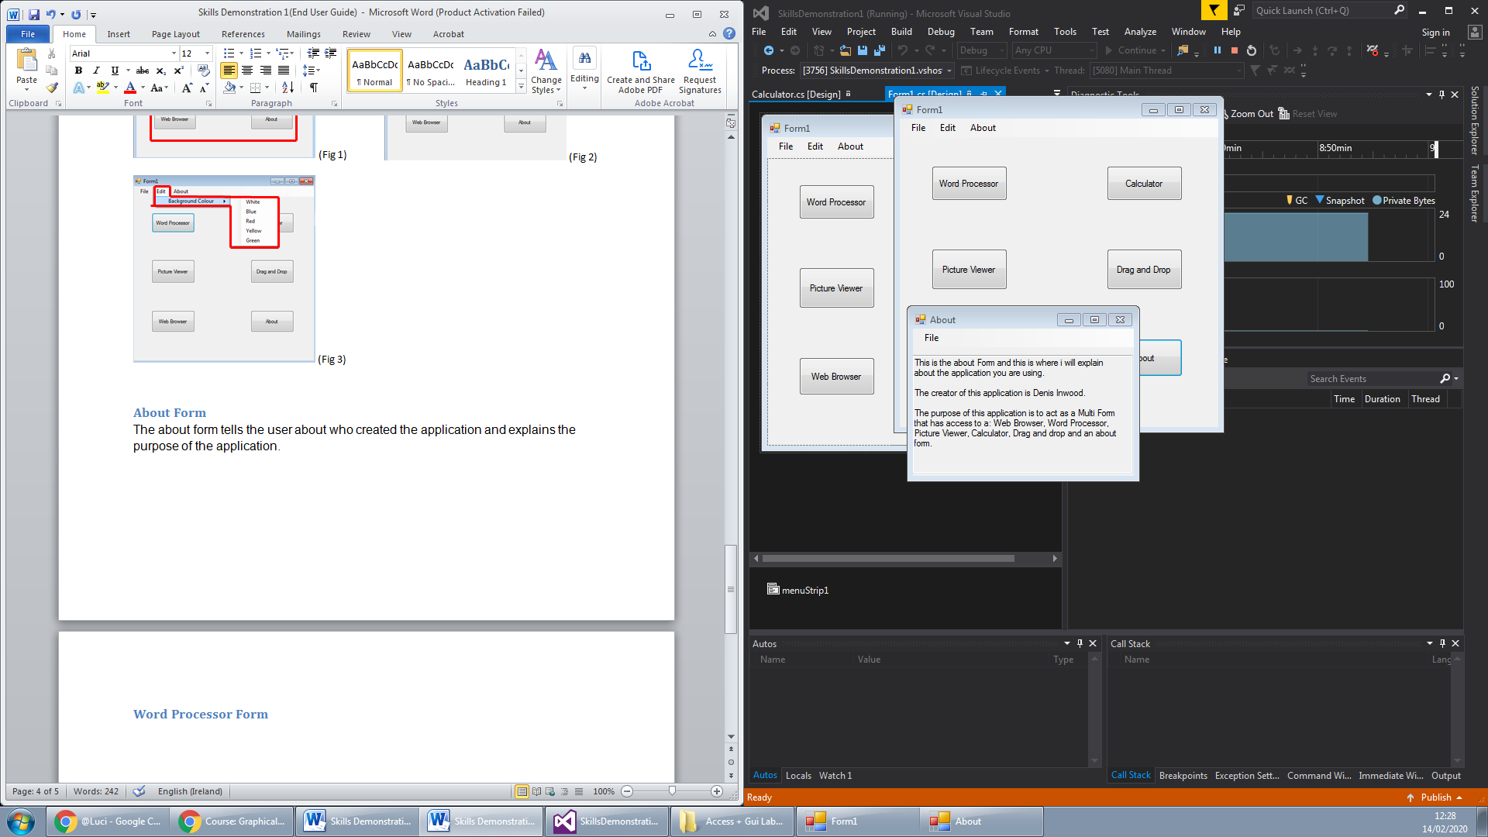 (Fig 4)

## Word Processor Form

The word processor is a text writing program which has some of the same uses as Microsoft word or notepad (Fig 5). You can save files open previous text files and also you can print the text that you have written (Fig 6). The text that you write you can edit that text’s font size and type, font colour and also background colour (Fig 7).

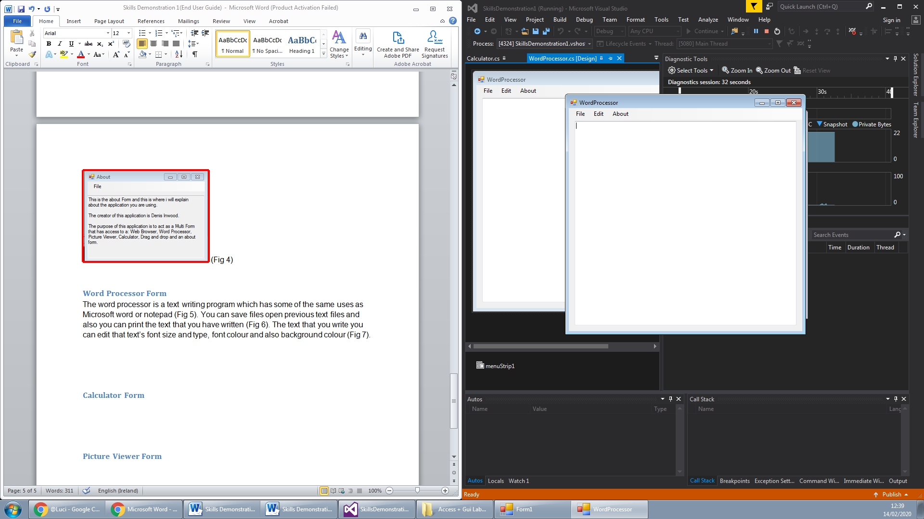 (Fig 5)

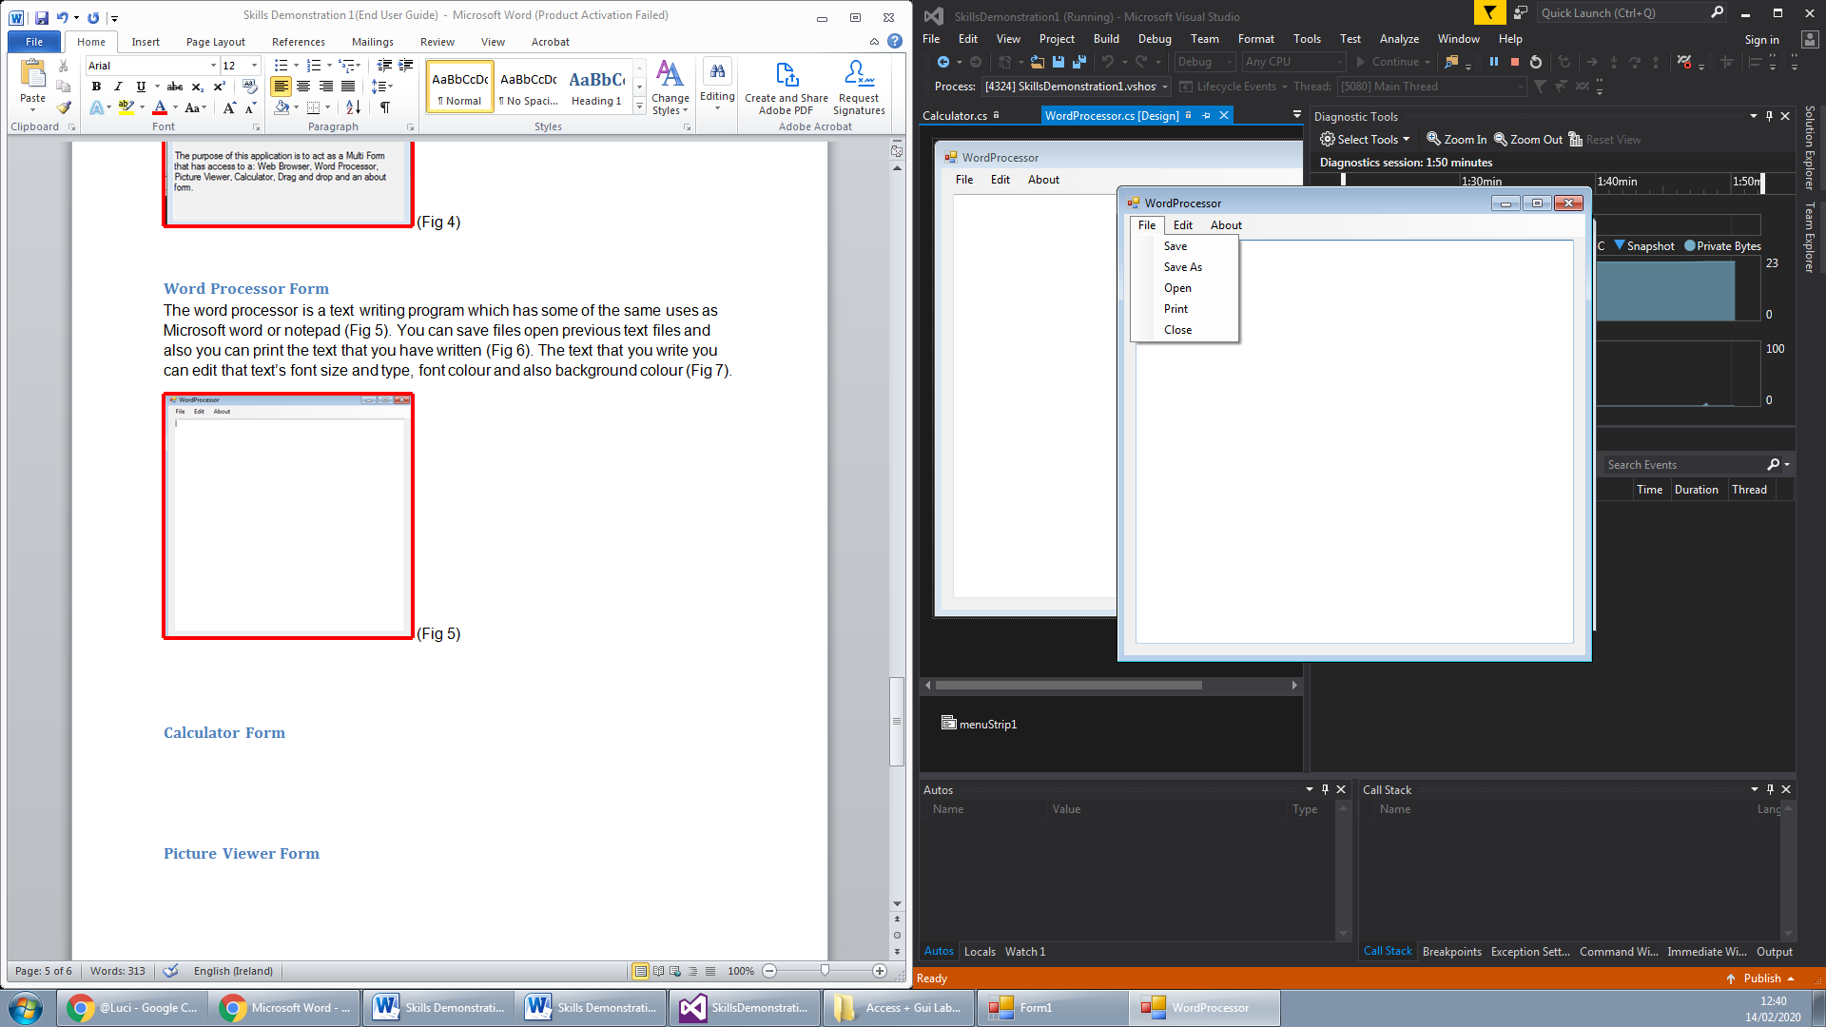 (Fig 6)

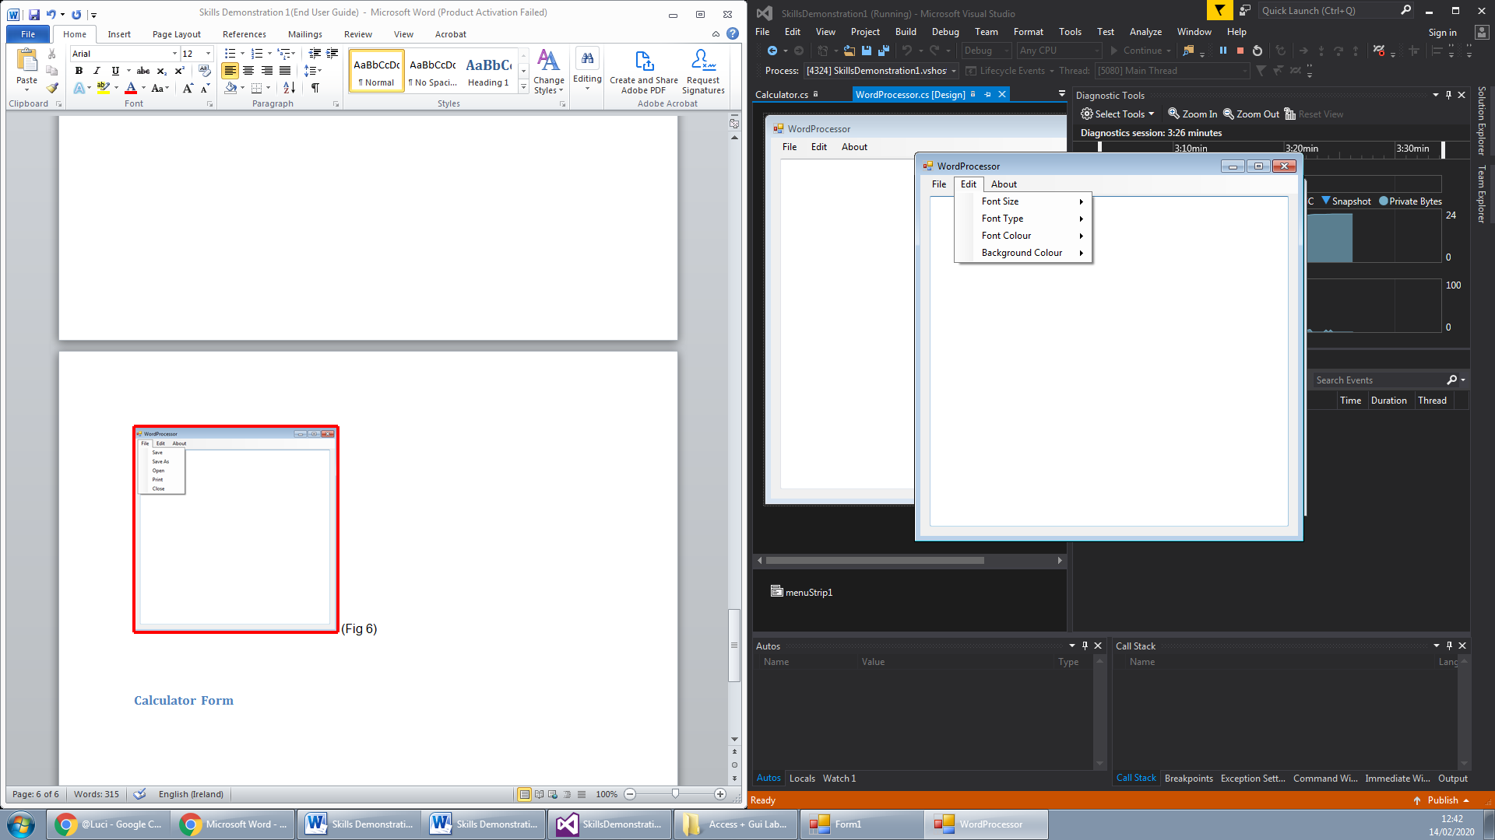 (Fig 7)

## Calculator Form

The calculator program is a base calculator that you can do simple calculations on (Fig 8). You can do addition, subtraction, multiplication and division using the buttons shown (Fig 9). You can also clear the calculator using the AC button (Fig 10).

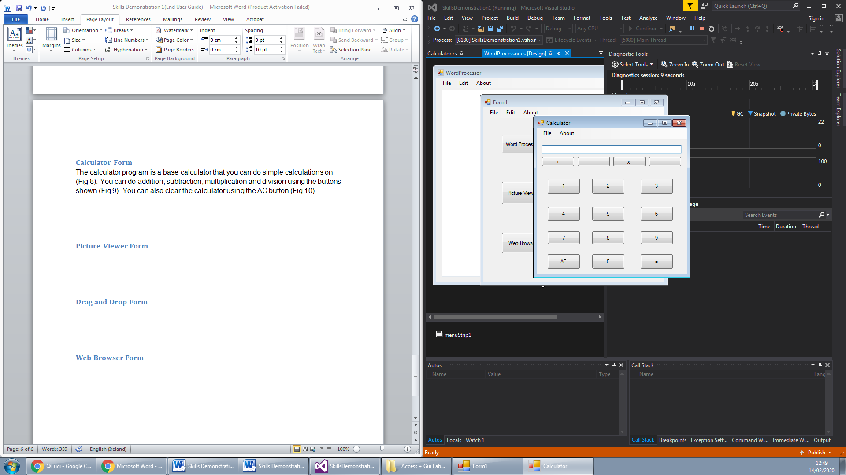 (Fig 8)

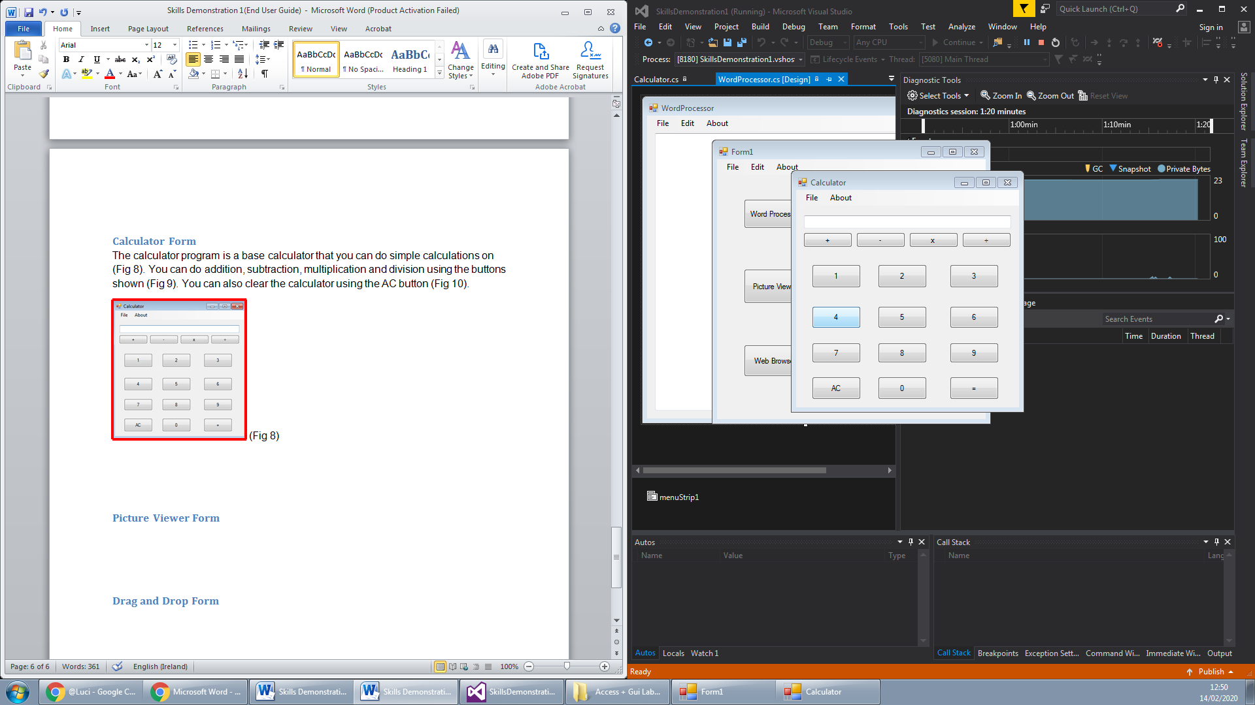 (Fig 9)

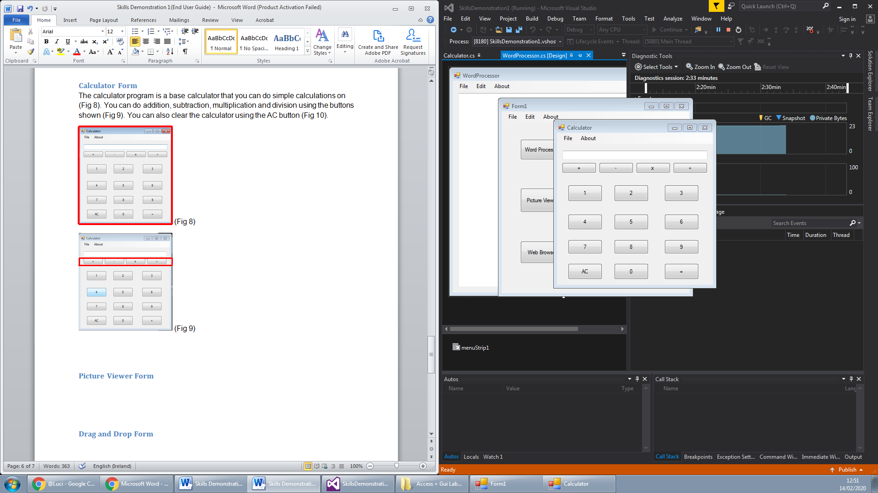 (Fig 10)

## Picture Viewer Form

The Picture Viewer is an application that allows for the user to view pictures that he has saved to his storage (Fig 11). You can open the pictures through the file menu strip at the top (Fig 12). Also if the user wishes to save the image that has been put onto the picture viewer to another location he can save it through the file menu as well (Fig 12).

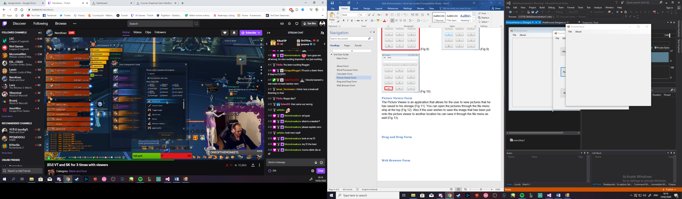 (Fig 11)

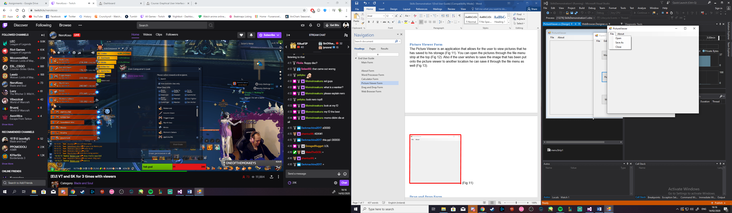 (Fig 12)

## 

## Drag and Drop Form

The Drag and Drop form is a program that allows the user to drag and drop text or images onto the interface and it will appear on the program (Fig 13).

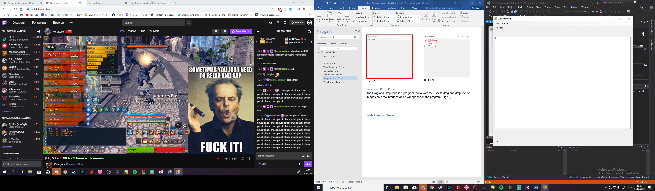 (Fig 13)

## Web Browser Form

The Web browser program is a program that is within the application that works as a search engine for the user (Fig 14). It works just like a web browser and you can search the web and use the usual function of a web browser, H stands for home, Go stands for search, < stands for go back, > stands for go forward, R stands for refresh and X stands for stop (Fig 15).

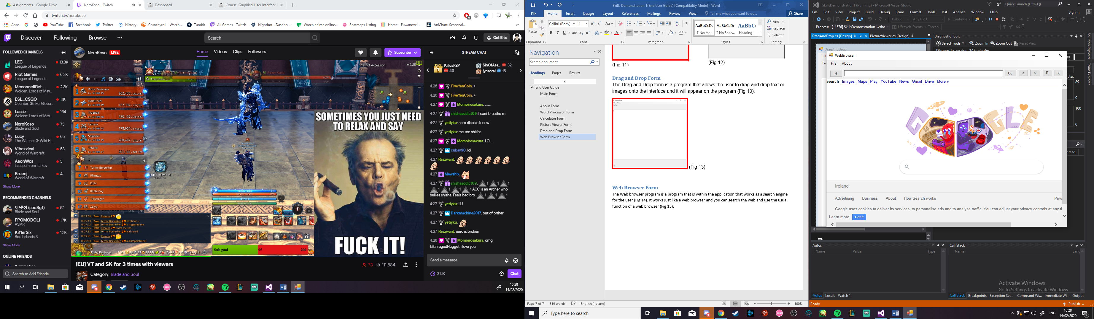 (Fig 14)

 (Fig 15)